

**ESBPII Assignment**

**Baremetal Virtual Machine Installation**

Samarasinghe R.W.H.V

IT13131784

**Open vmware workstation**

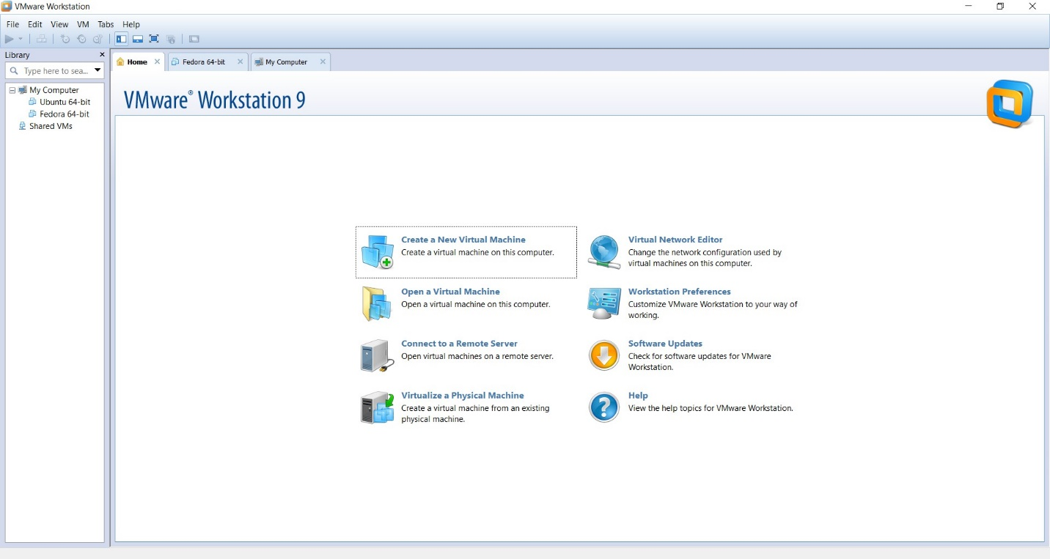

**Go to file and select new virtual machine and select typical**

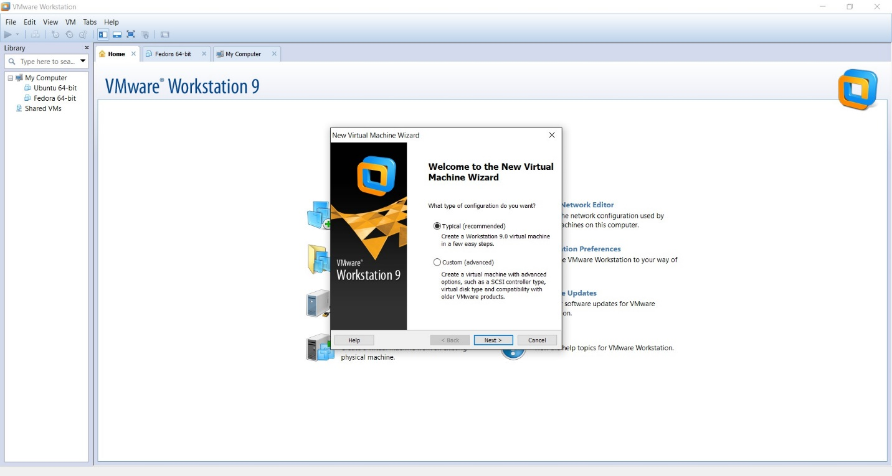

**Select the image to install the OS**

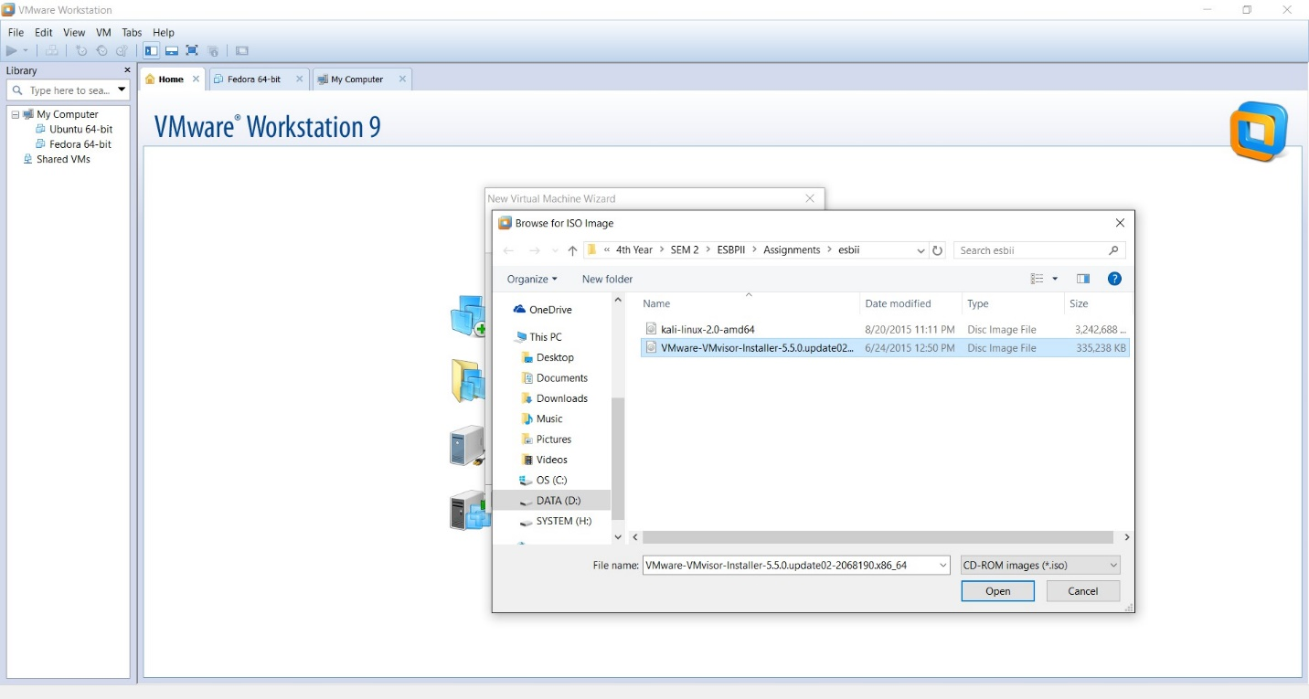

**Select the location to install the OS**

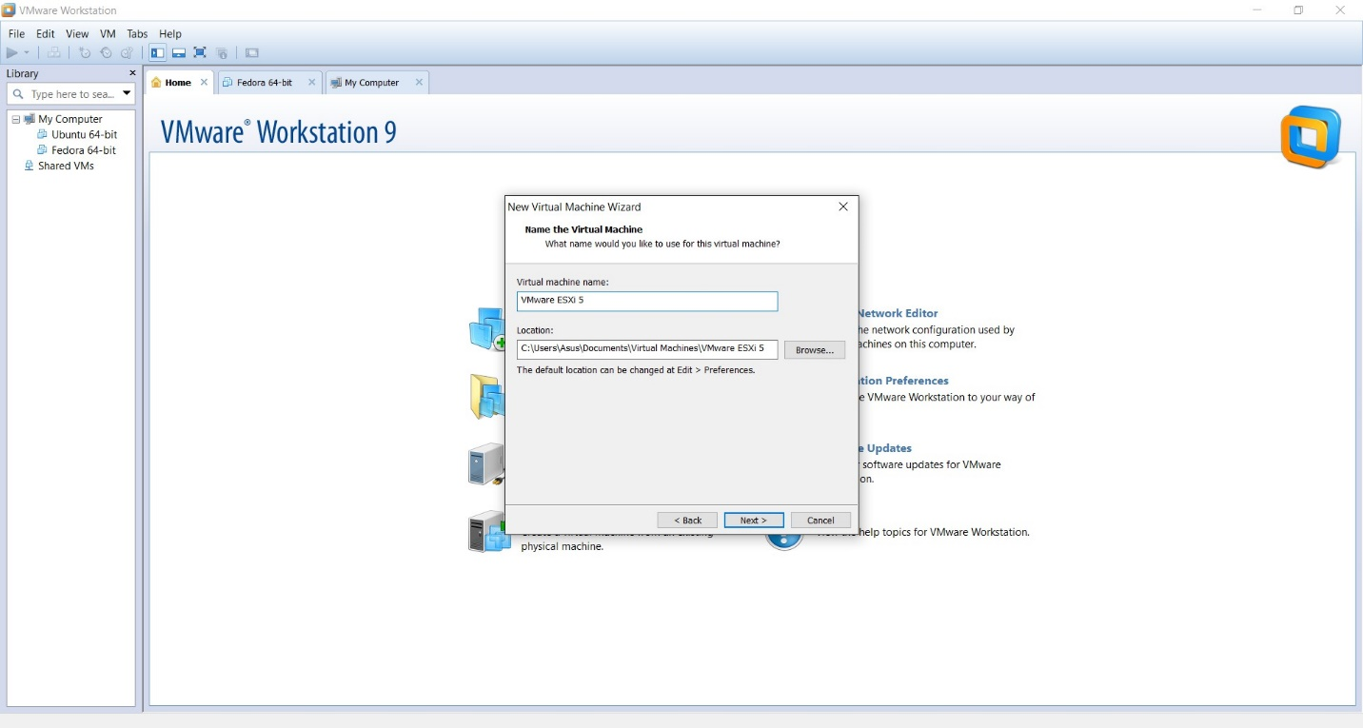

**Select store as single file and give the space as 40GB**

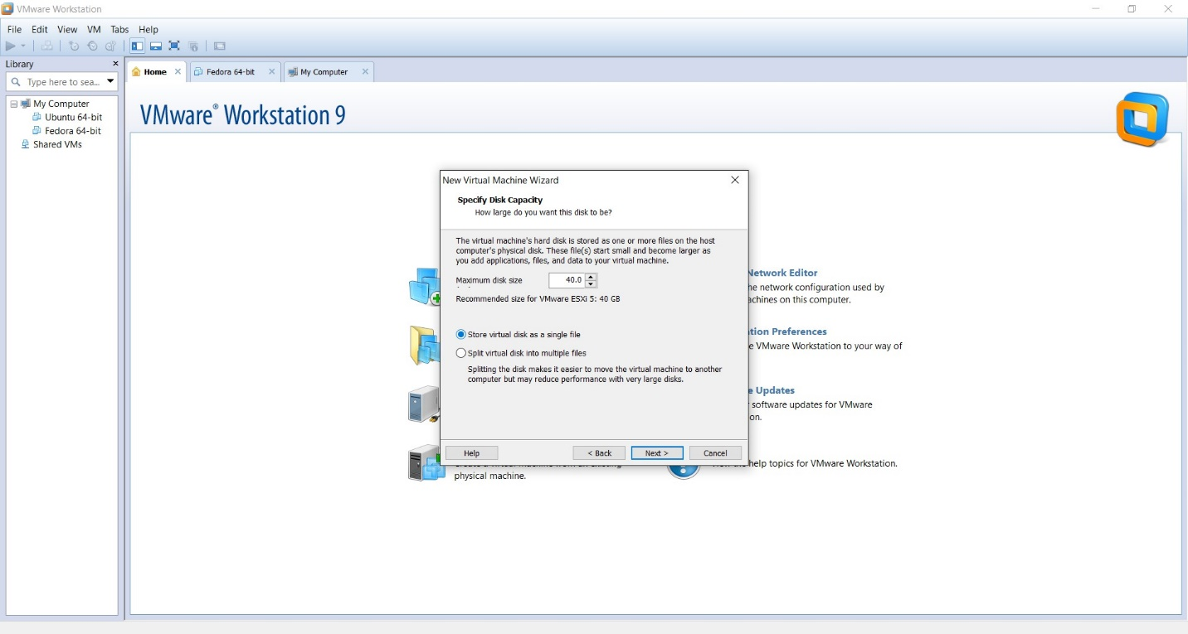

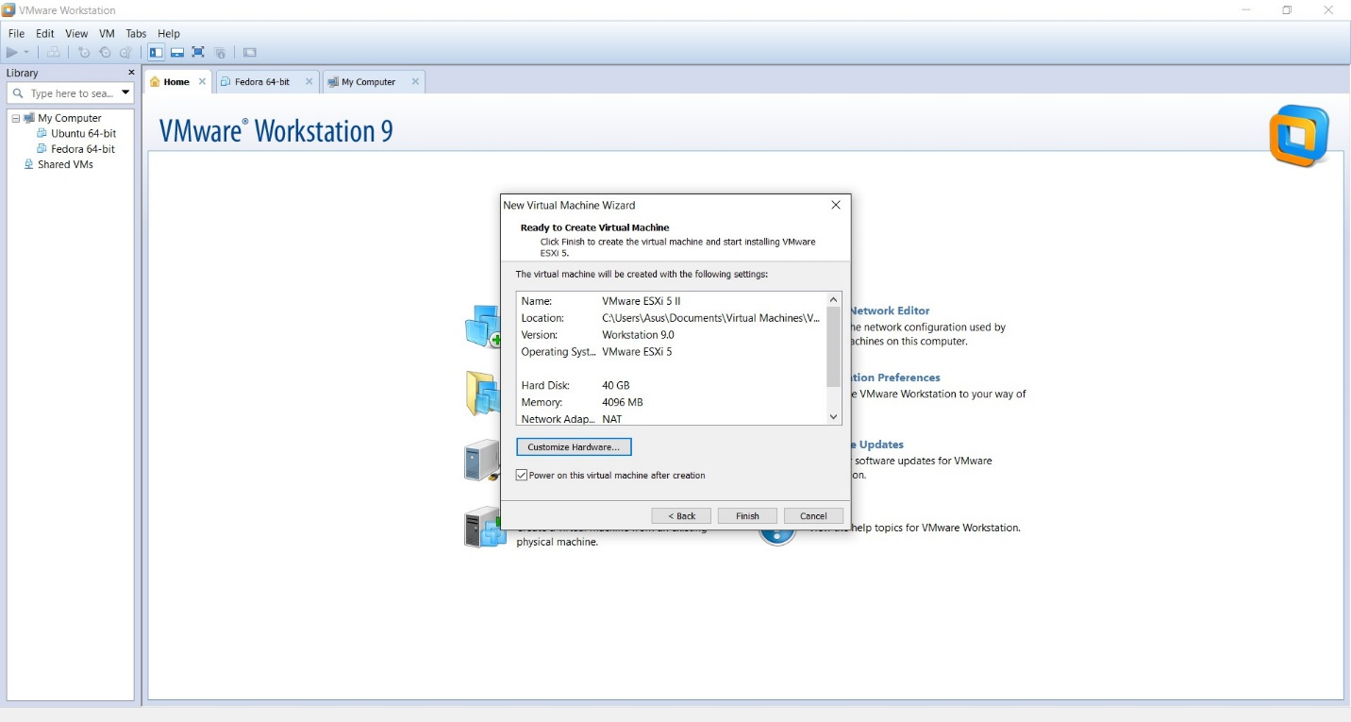**Select the customize hardware and select the memory as 4GB and click finish**

**Click ok and don’t change the default selected one and wait until load**

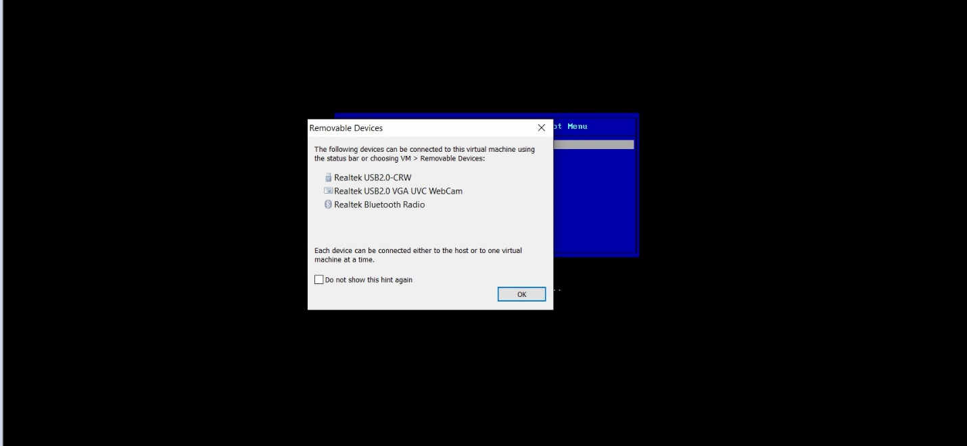

**Loading will start and give a message after that load is successful**

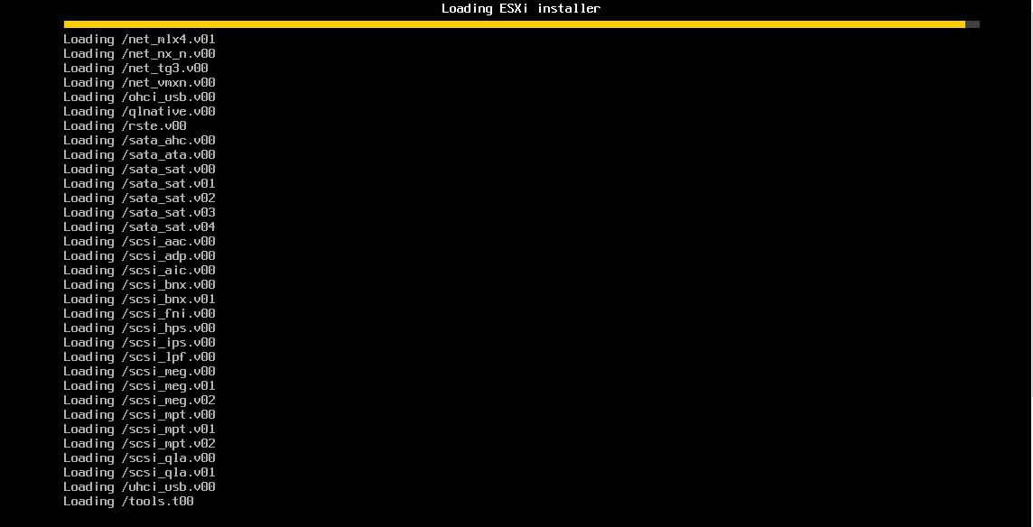

**Click Enter and continue**

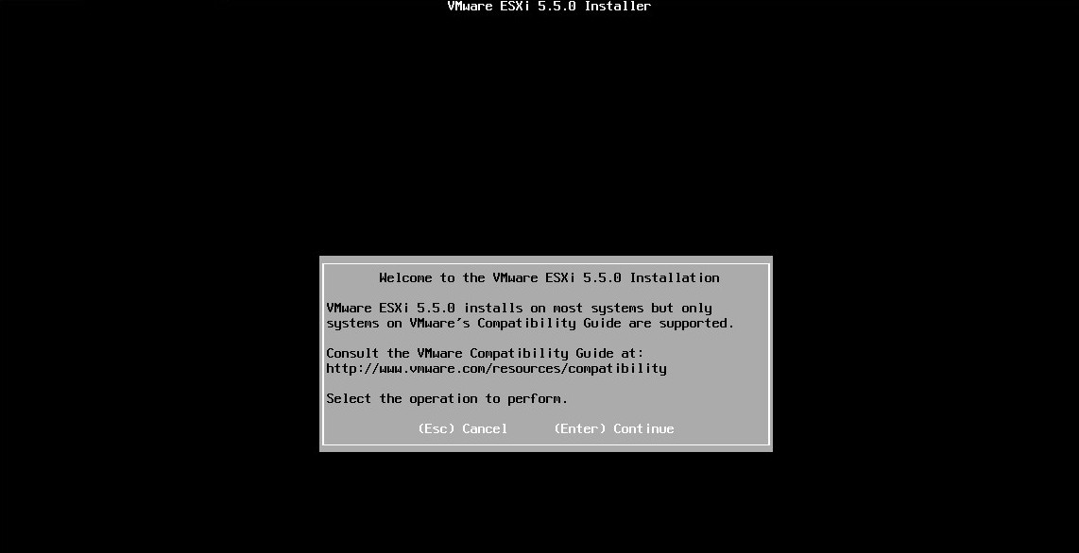

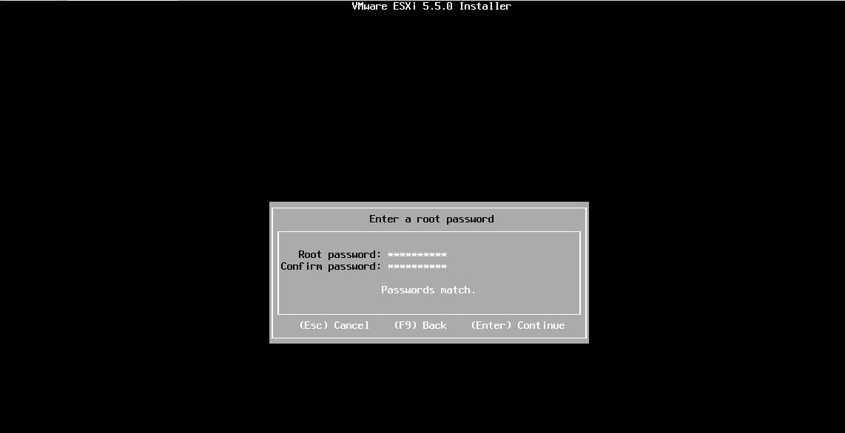**Give the root password**

**After selecting the F11 the installation starts**

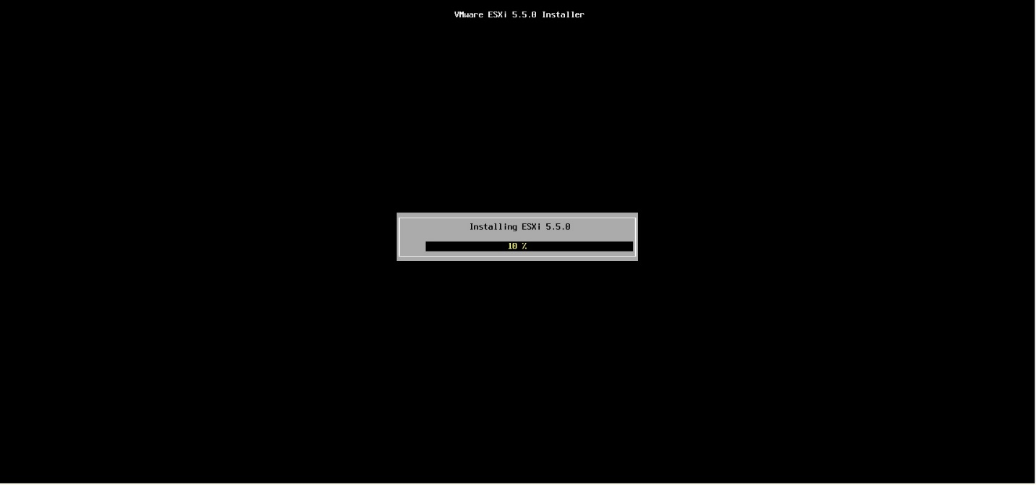

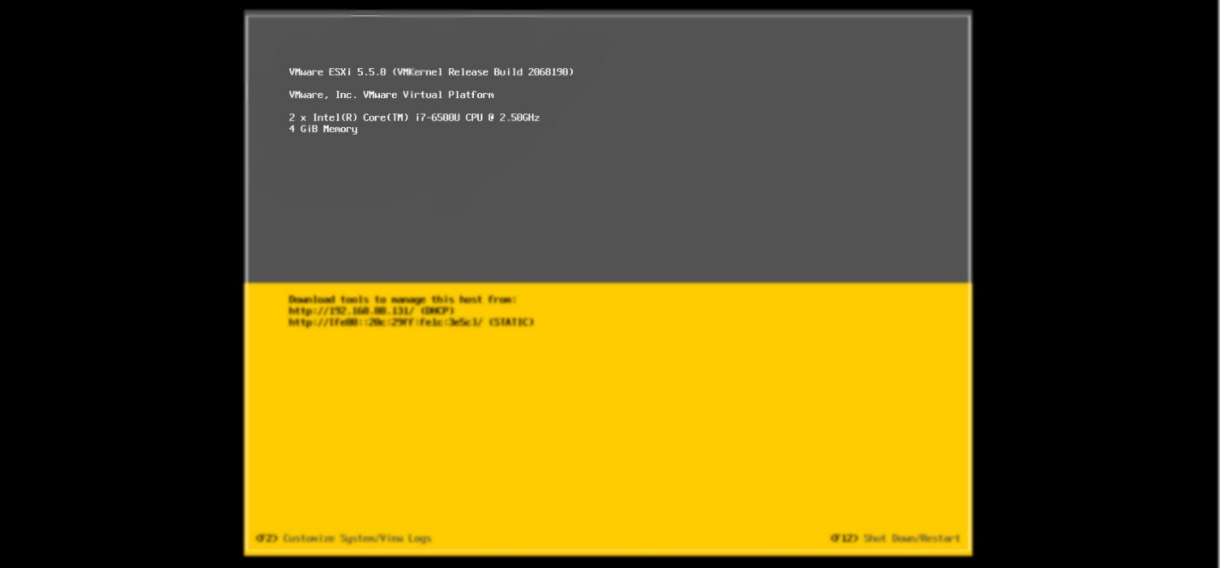**After installation it will show this window, then copy this IP address and past it in your browser and go to that site and download the VMware-viclient**

**After downloading open it then it will extract**

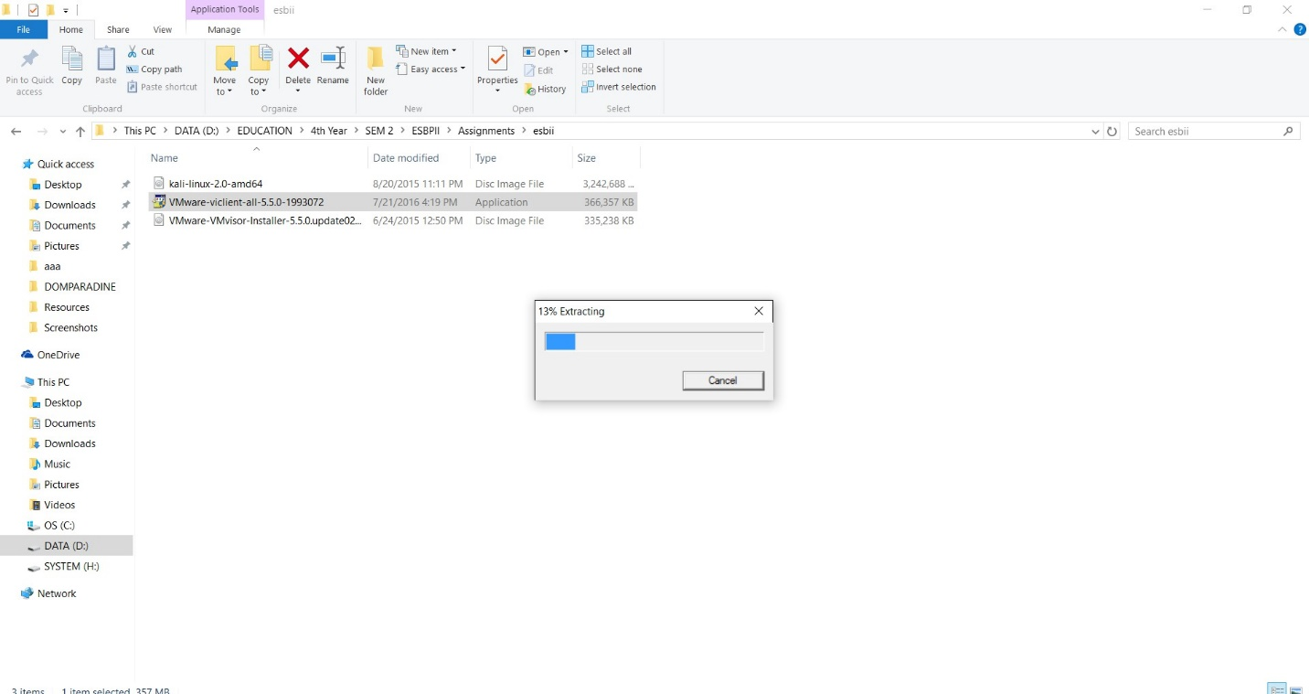

**After extracting it will start to install**

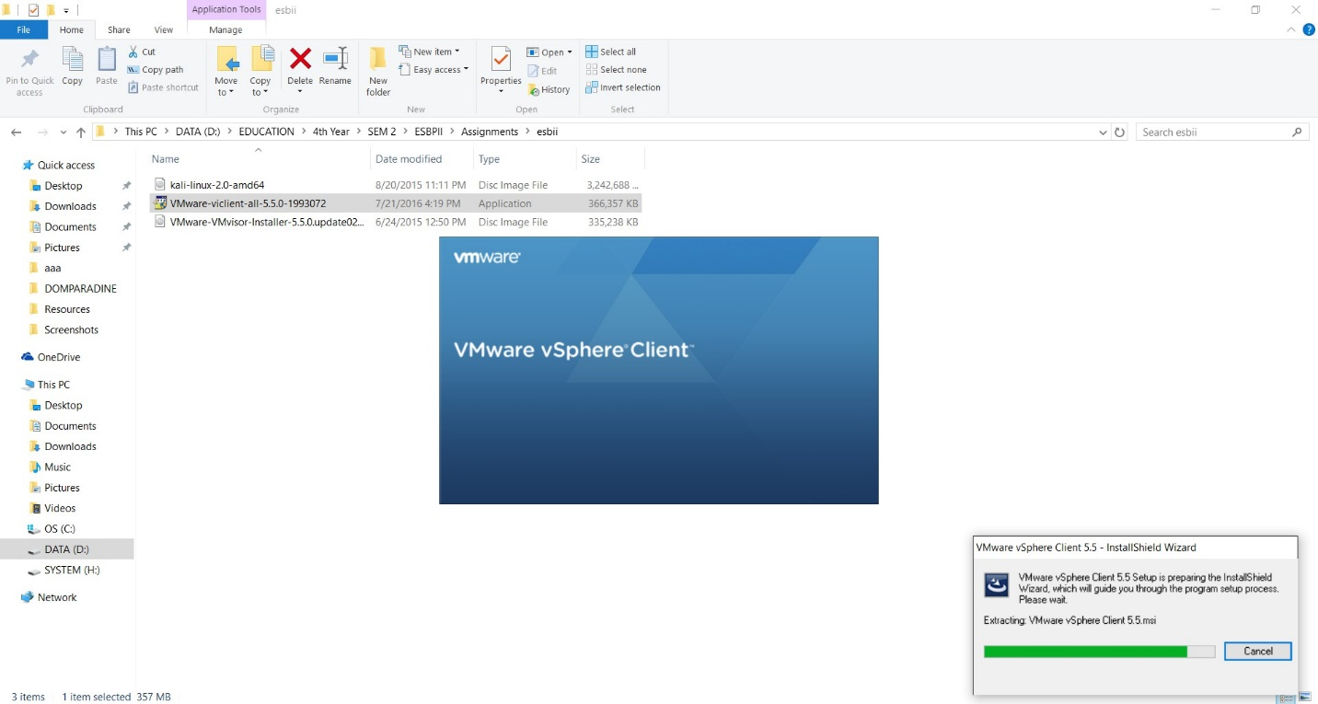

**Select “automatically close and attempt to restart” option and click ok**

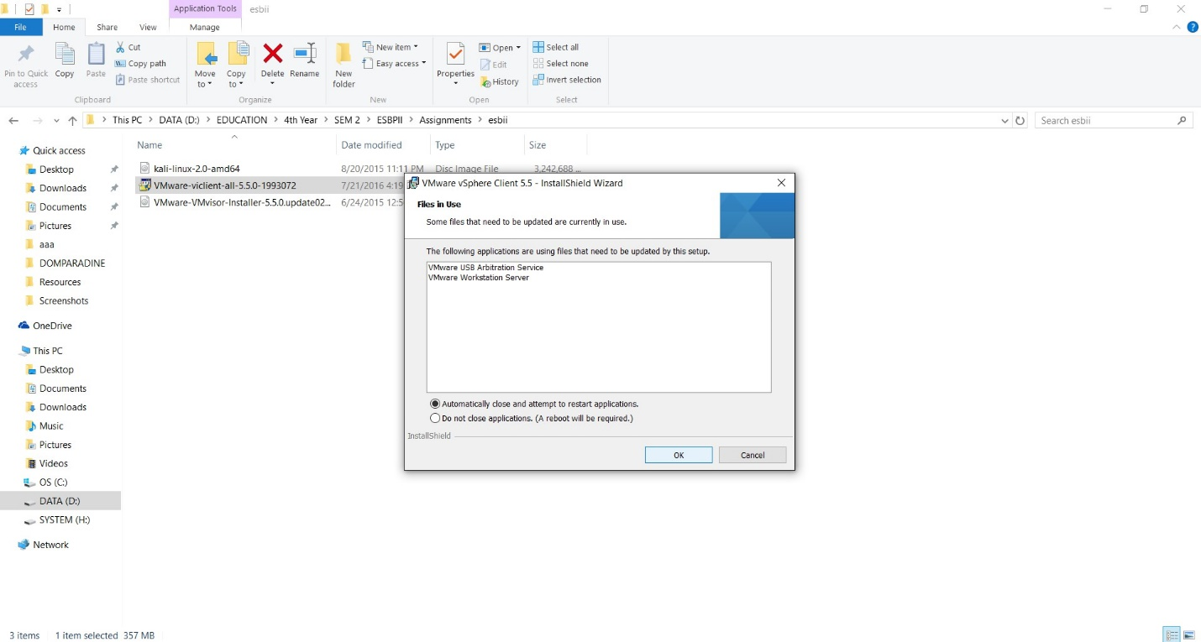

**After installation click the finish**

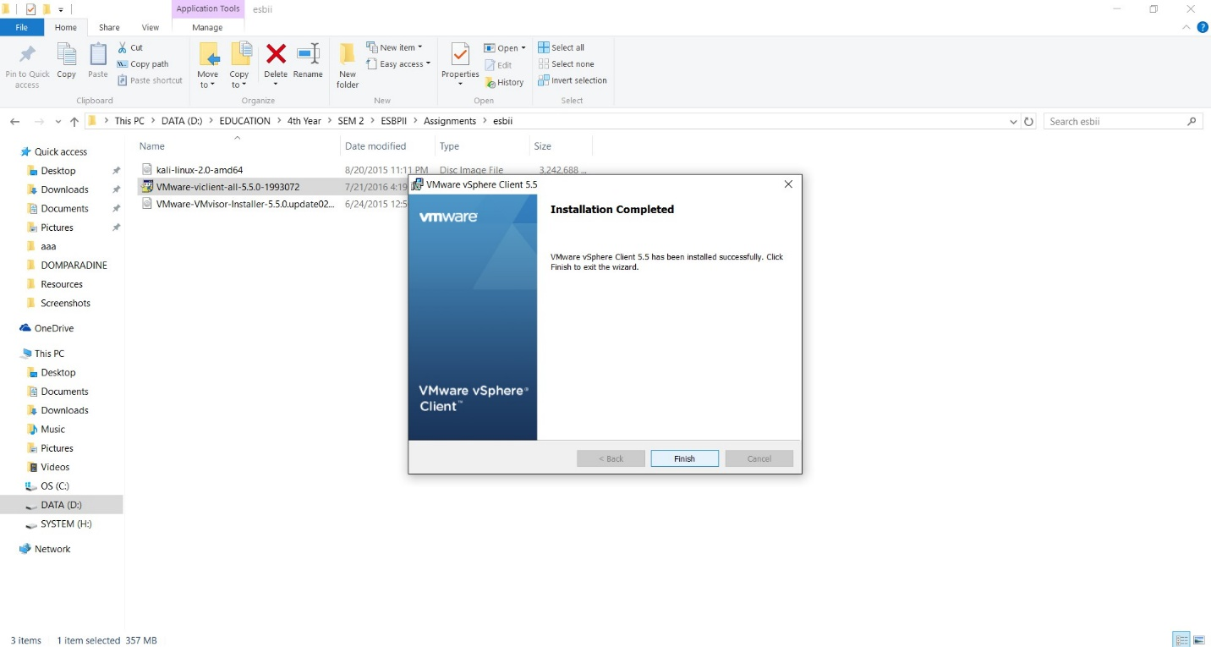

**Open the vSphere Client software and fill the blanks with the earlier IP address and the username as the root and type the password we earlier gave**

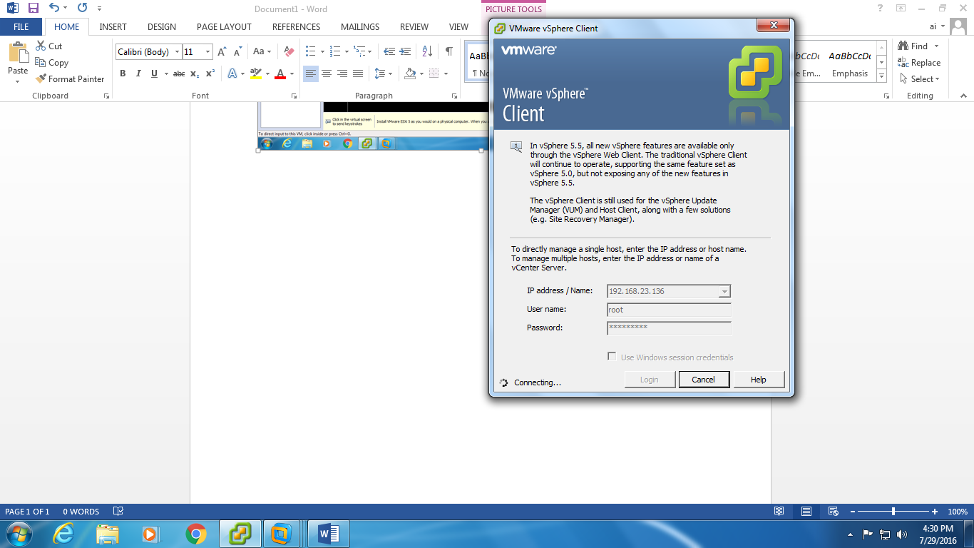

**After successfully connected it will show this window then click the inventory and open it**

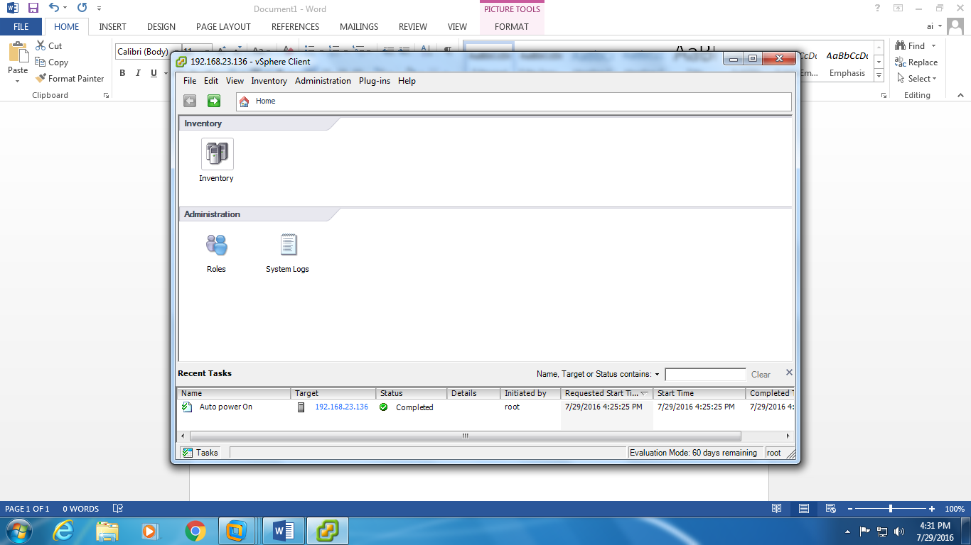

**Right click the IP address and select the create a new virtual machine**

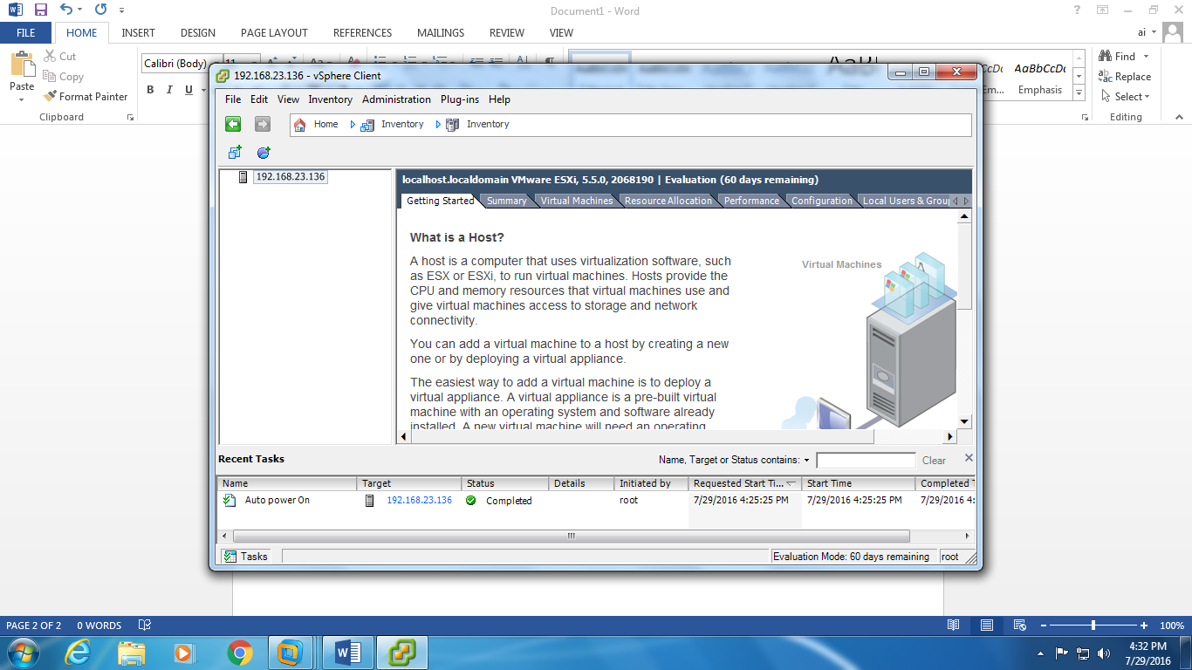

**Select typical and click next**

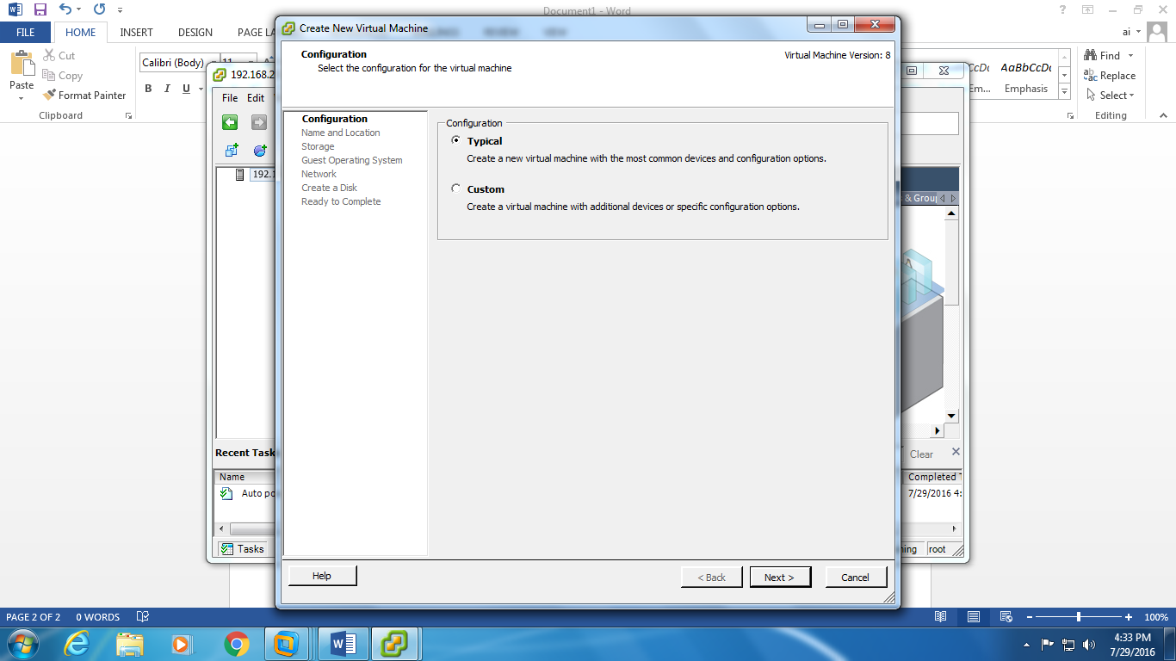

**Select the storage as “darastore1” and click next**

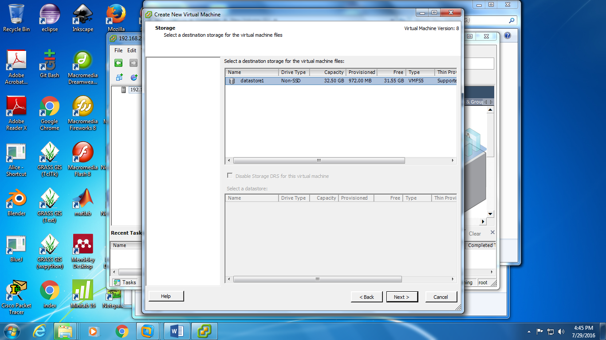

**Select Linux and click next**

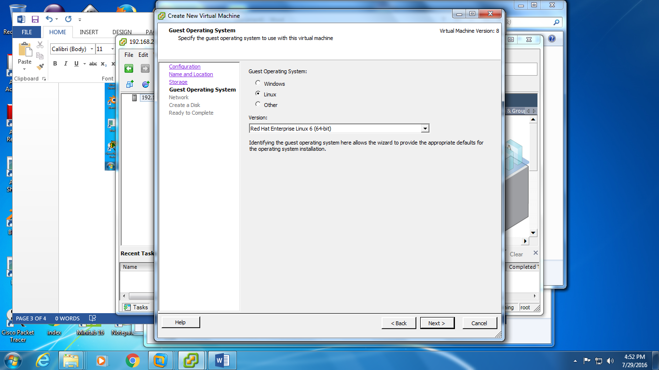

**Select “E100” as the adapter and select the “connect at power on” and click next**

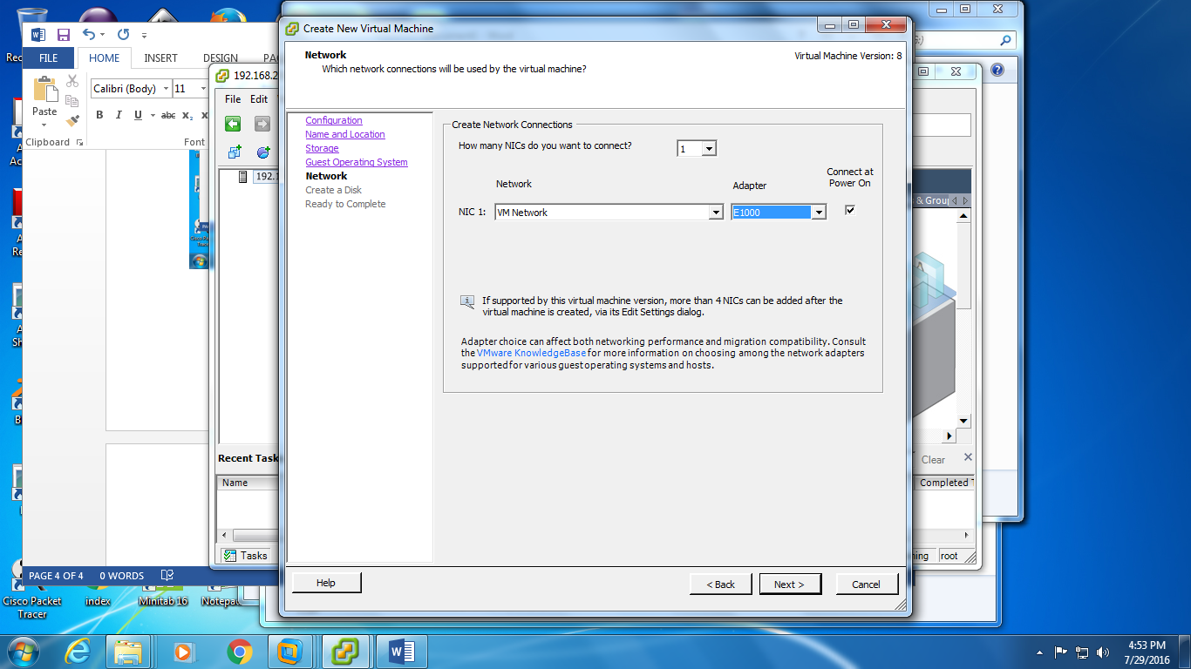

**Select the “thin Provision” and don’t need to change the disk size (we can change the hard disk size later in “edit virtual machine settings”) and click next**

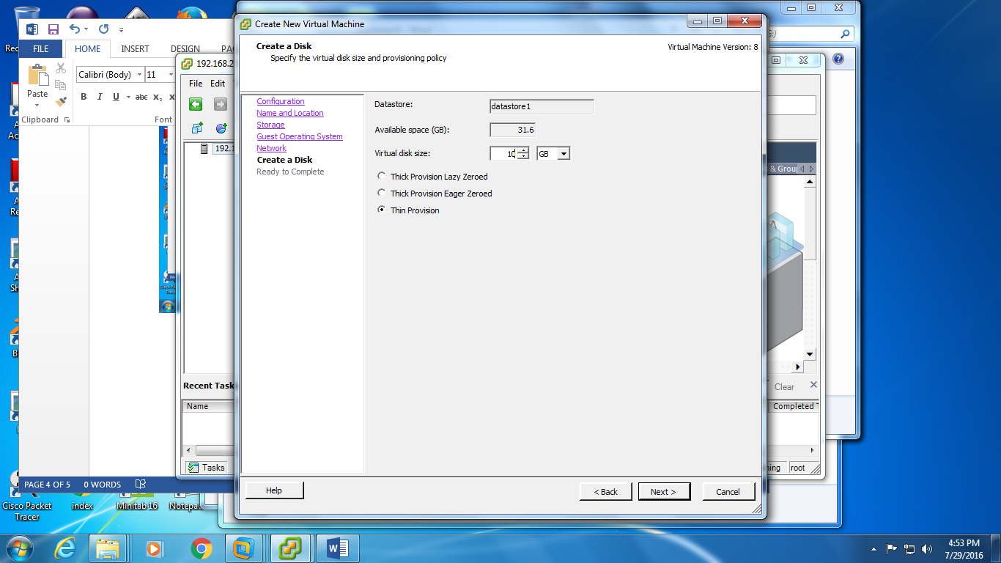

**Right click the datastore1 and select “Browse Datastore”**

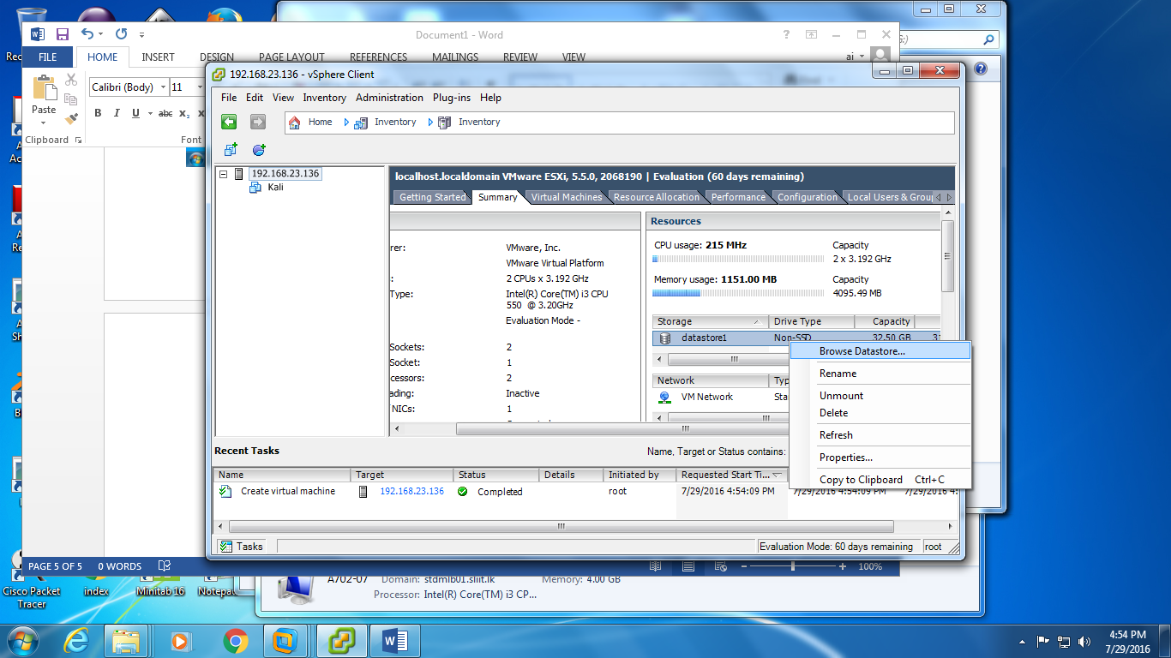

**Select upload file and select the kali image file**

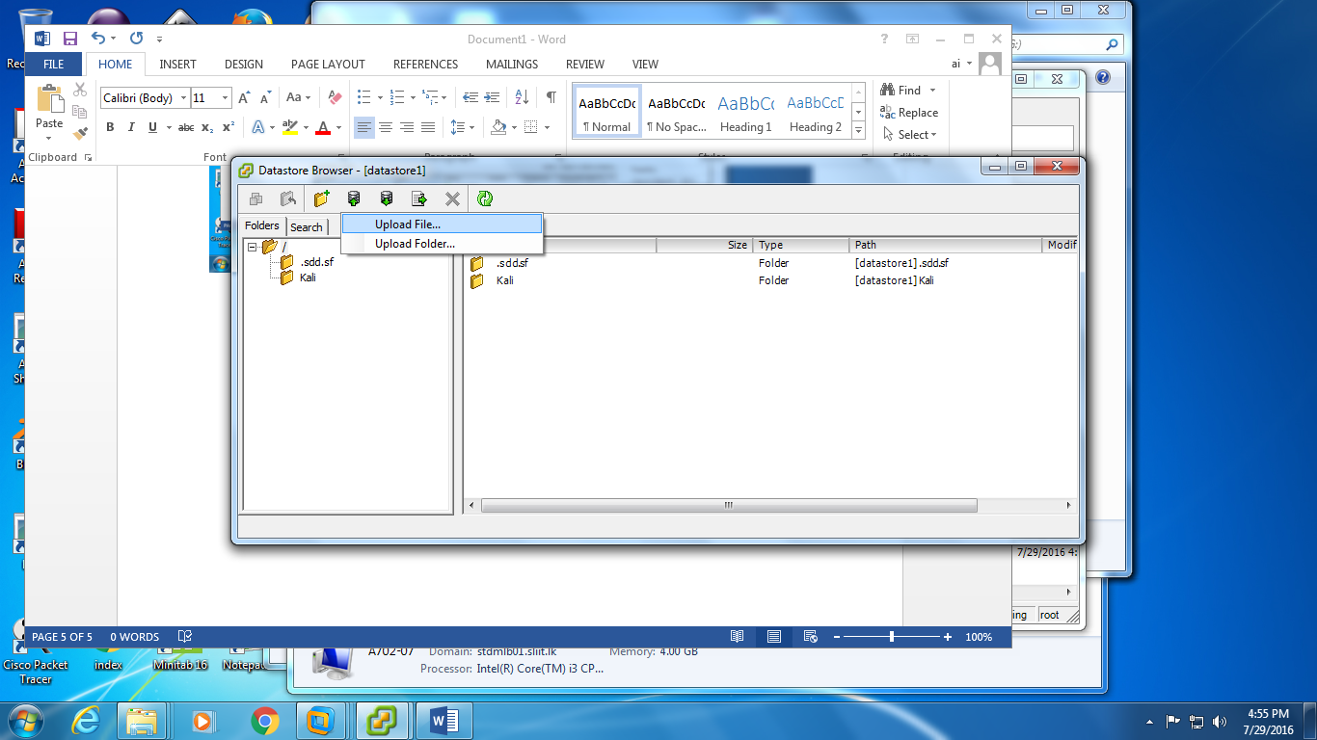

**Kali image file will uploaded to the datastore1**

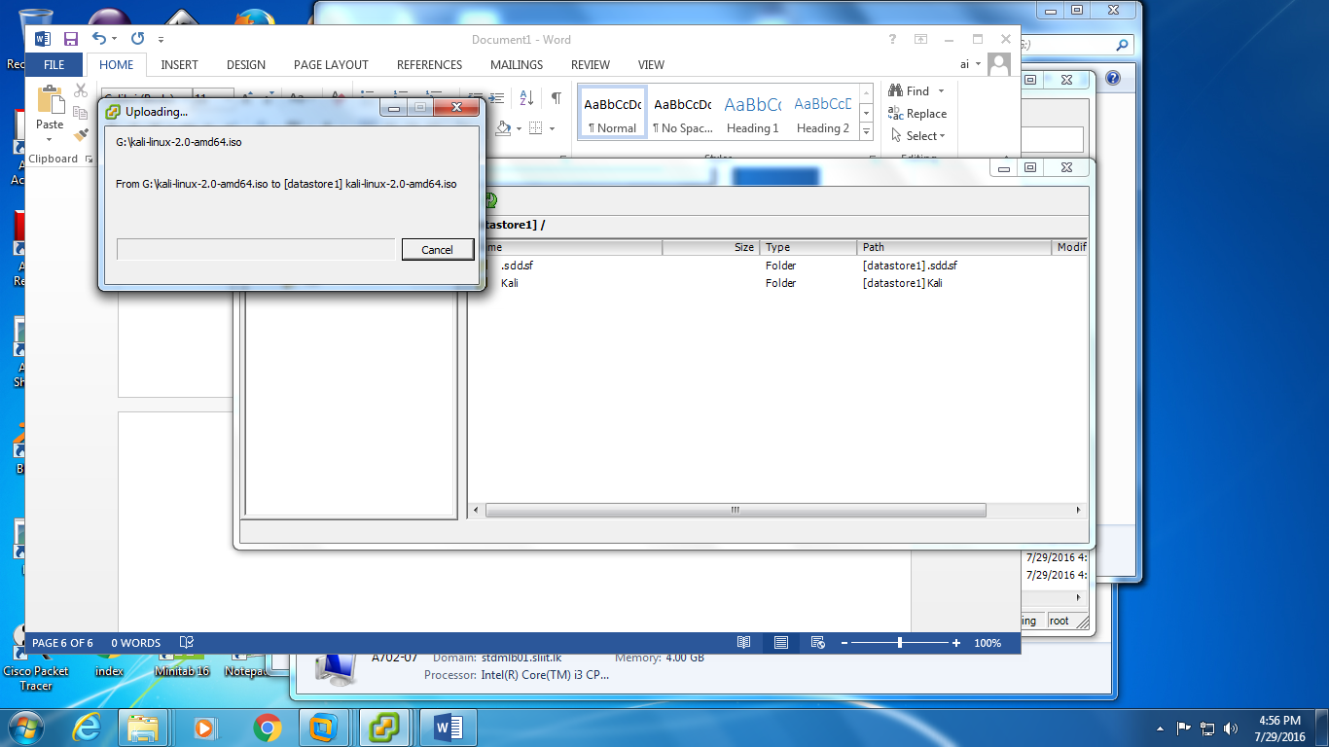

**Right click on the earlier created virtual machine and select edit settings**

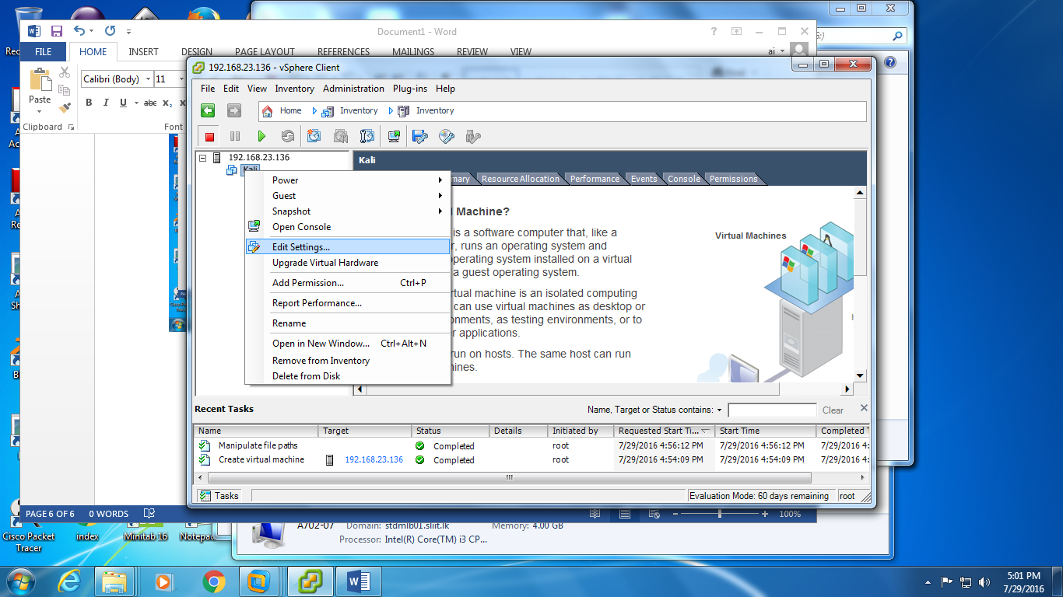

**Select the “CD/DVD drive1” and in that select the “Datastore ISO file” click browse and select the kali image**

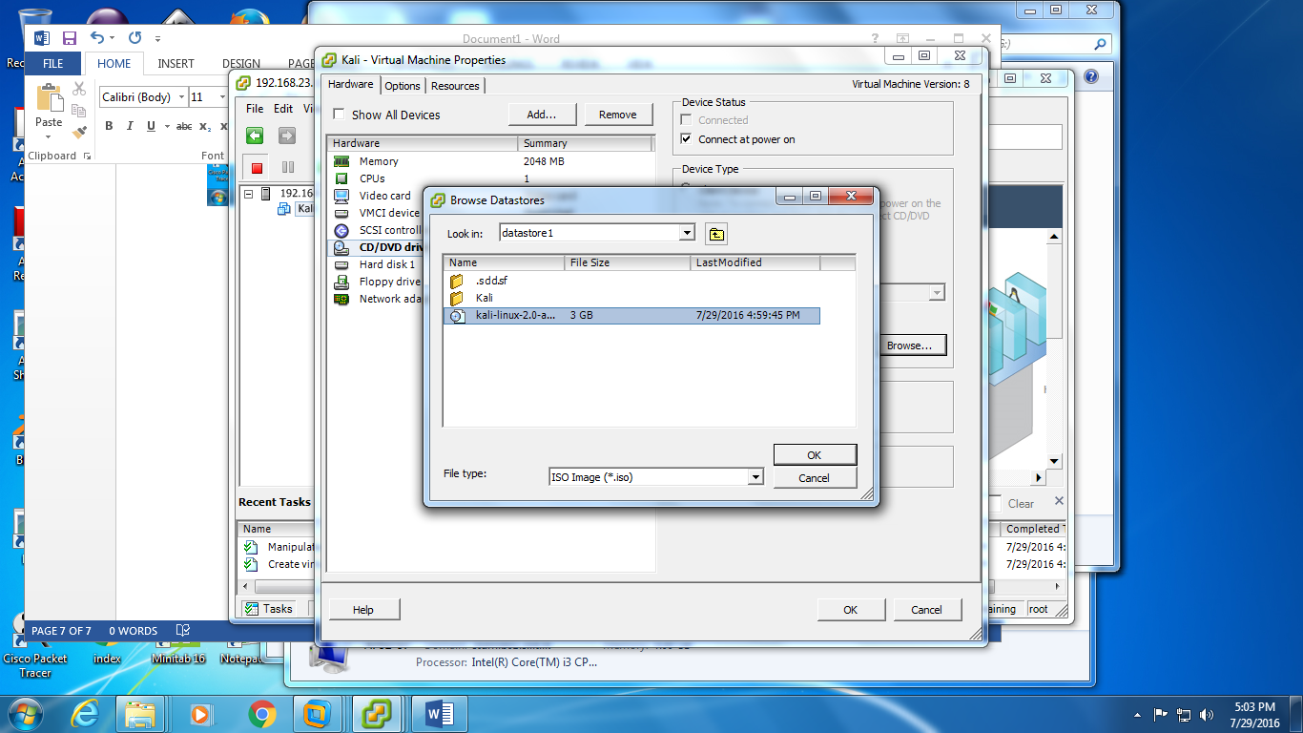

**Put a tick on the “Connect at power on” and click ok**

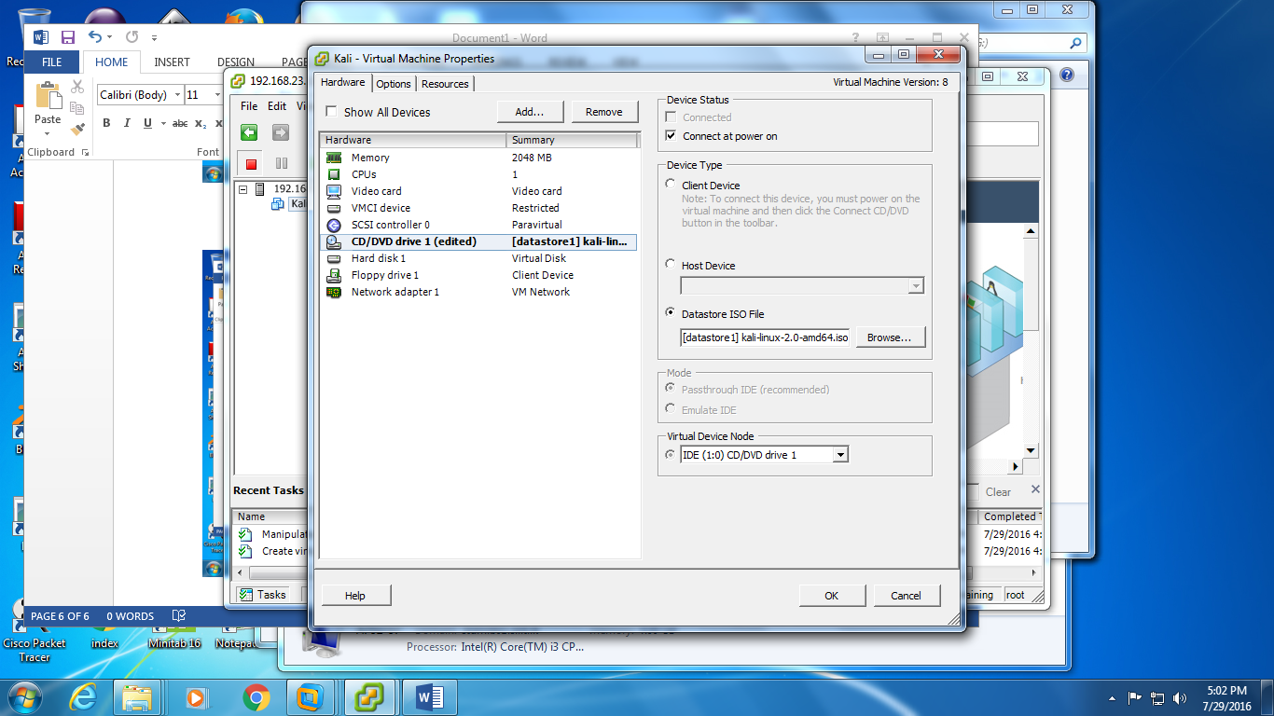

**Select memory size as 4GB**

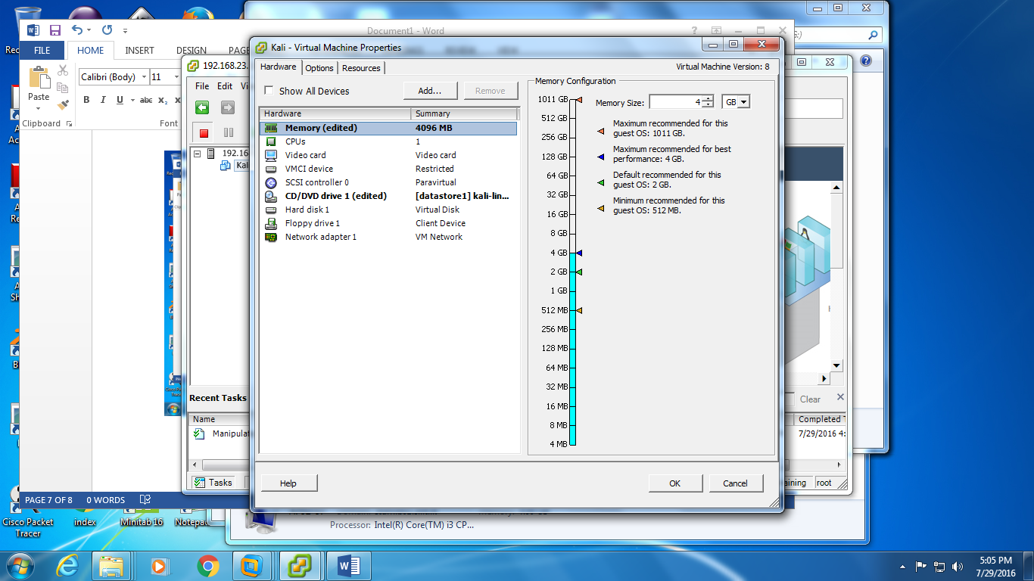

**Select hard disk1 size as 20GB**

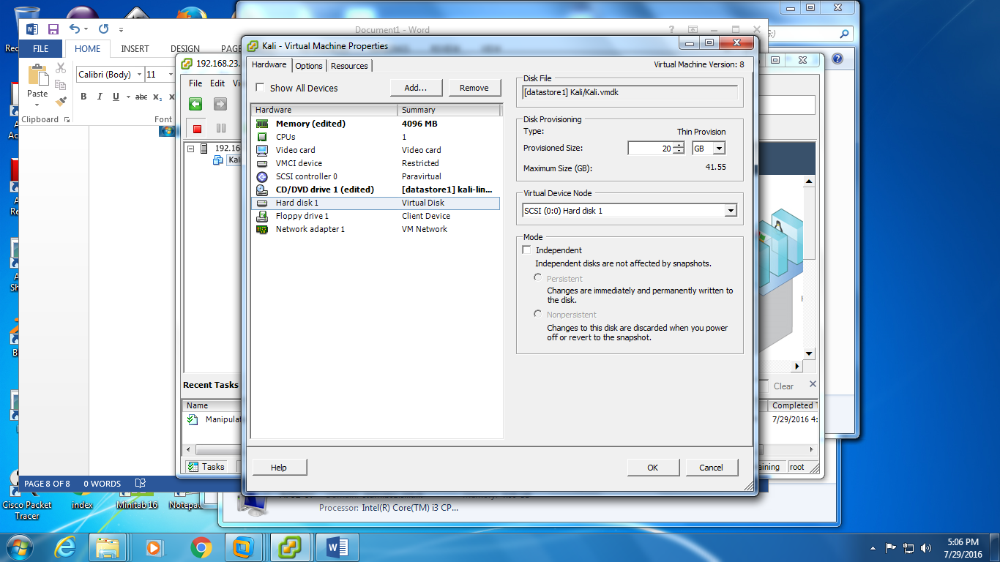

**Right click on virtual machine and select power on**

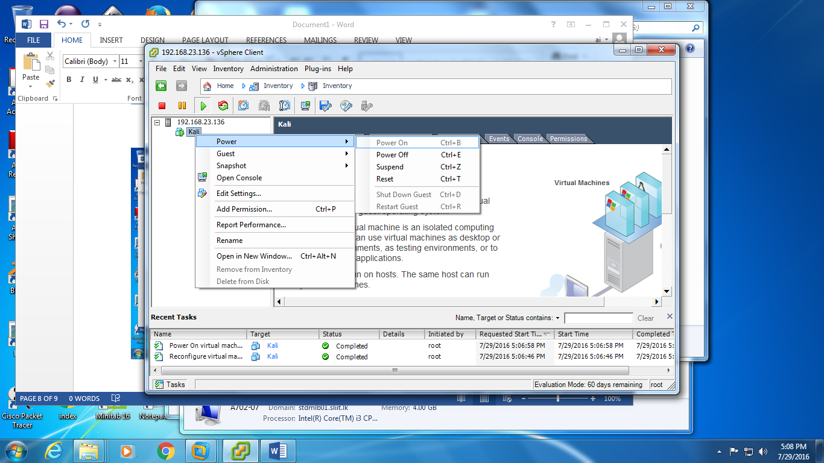

**Select the console it will show the Kali boot menu select the “Live (amd64)”**

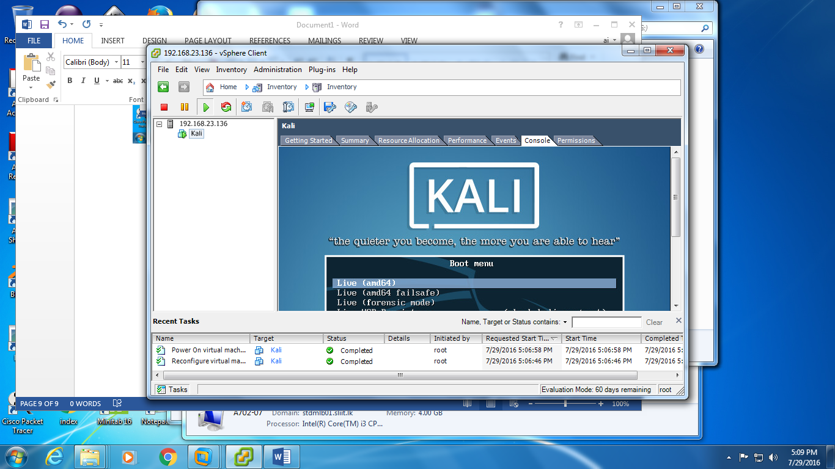

**Then Kali OS will load**

